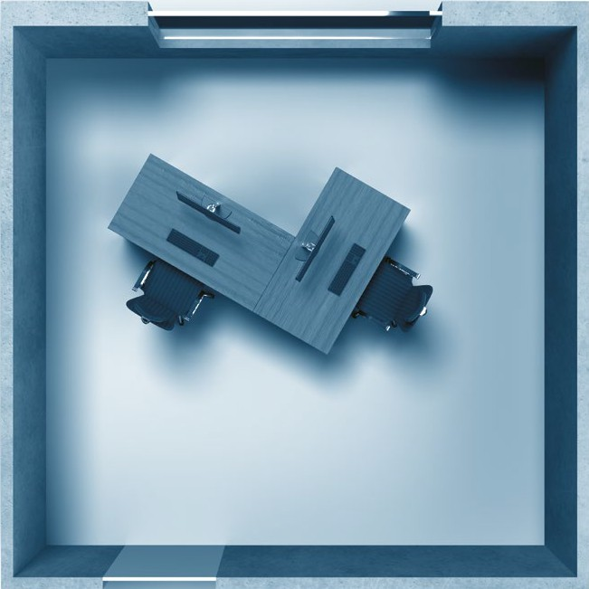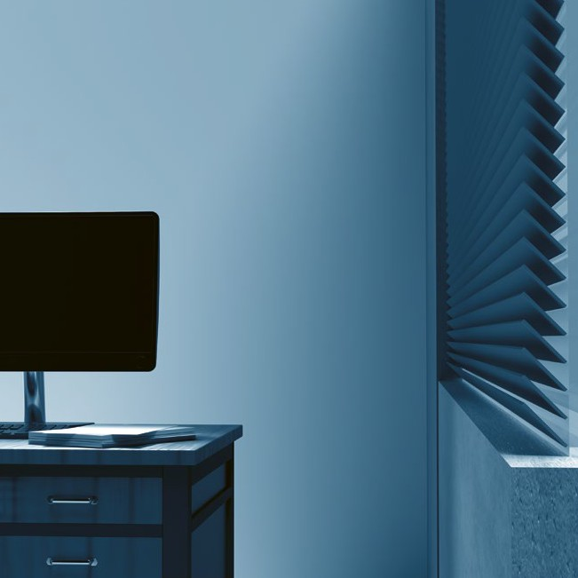

**Prepare for Drones**

**Prevent Drone Observation**

**Drones always have cameras!**

* Turn your screen away from your window.
* Lower shutters and adjust them at an upward angle.
* Cover whiteboards and flipcharts after use.
* Handle classified and proprietary documents with care, stow them away or cover them if not in use.

Screen Visibility

**Mitigate Blast Effects**

**Drones may carry explosives!**

* Arrange your workplace at a distance to windows. Blast decreases exponentially with distance, just a little space can make the difference.
* Make yourself familiar with the drone assembly points. The drone is outside – stay inside.

**Prepare against Cyber Attacks**

**Drones may fake your wireless network!**

* Clean your Wi-Fi List and delete all unsecured networks.
* Configure your mobile device so you have to confirm each connection attempt.

Visit [**www.japcc.org/drone-drills**](http://www.japcc.org/drone-drills)to learn more about drone threats and how to prepare for them.

Line of Sight

180˚

© JAPCC

180˚

**Imagery Front Page**

Drone Evacuation Point Sign – Drone: © AdobeStock, 260694458 (10 November 2023); Shield: © Copyrighted; Group: FourLeafLover – stock.adobe.com; Arrows: © Copyrighted Prevent Drone Observation (top/front view): © JAPCC; © Adobe (3D Objects)

Logo Headline – Shield: © Copyrighted; Drone Parts Next to Shield: © 1arts – stock.adobe.com Lock/Mobile Arrangement: © Adobe

*Please visit*

[***www.japcc.org/drone-drills***](http://www.japcc.org/drone-drills)

*to download customizable templates for the annexes included in this paper, as well as additional educational references and materials.*